BRAINWARE UNIVERSITY
ML PROJECT-BASED LEARNING REPORT (WEEK 2)
1. Basic Information
Title of the Project: | Electricity Bill Calculator & ATM Transaction Simulator (Program 1 & 2)
Name(s) of Student(s): | Soumyadwip Das (BWU/BTS/25/169)  Ankita Paul (BWU/BTS/25/180)  Sonia Naskar (BWU/BTS/25/195)  Joyeta Mondal (BWU/BTS/25/214)  Sayantan Bharati (BWU/BTS/25/503)
Programme & Semester: | B.Tech CSE & 3rd Semester
Course Name & Code: | Python Programming Lab (BES09013)
Name of the Guide/Supervisor: | MR. PRANAB GHARAI & MR. INDRANIL DAS
Project Date | 17/07/2026

2. Introduction and Background
Week 2 focused on developing two console-based Python applications: an Electricity Bill Calculator and an ATM Transaction Simulator. The programs apply core Python concepts such as conditional logic, functions, dictionaries, and menu-driven control flow, using in-memory data storage and a consistent boxed terminal interface.

3. Objectives of the Project
3a. Objectives - Program 1: Electricity Bill Calculator
- Develop a menu-driven electricity bill calculator.
- Implement slab-wise billing logic.
- Apply discount and fixed service charge rules.
- Store user records using dictionaries.
- Validate user input.
3b. Objectives - Program 2: ATM Transaction Simulator
- Develop a console-based ATM simulator.
- Implement user authentication.
- Support balance enquiry, withdrawal, deposit, and PIN change.
- Store account details using dictionaries.
- Test the program with valid and invalid inputs.
4. Problem Statement / Driving Question
4a. Program 1: Electricity Bill Calculator
How can a terminal application accurately calculate electricity bills using slab-wise tariffs, discounts, and fixed charges while managing multiple user records?
4b. Program 2: ATM Transaction Simulator
How can common ATM operations be simulated securely in a console application while handling invalid credentials and transactions?

5. Methodology
5a. Methodology - Program 1: Electricity Bill Calculator
1. Program Design
- Developed a menu-driven interface with reusable box-drawing functions and an ASCII-art banner.
2. Billing Logic Implementation
- Implemented calc() to calculate slab-wise electricity charges, apply discounts, and add a fixed service charge.
3. Data Handling & Validation
- Implemented Stored user records in an in-memory dictionary and validated unit input using exception handling.
5b. Methodology - Program 2: ATM Transaction Simulator
1. Program Structure
- Created a boxed menu interface using reusable helper functions and an ASCII-art banner.
2. Account Data Modelling
- Stored account details in a Python dictionary containing card number, PIN, and balance.
3. Core Transaction Logic
- Implemented authentication, balance enquiry, withdrawal, deposit, and PIN change with necessary validation.
4. Menu-Driven Control Flow
- Built a continuous menu system and tested various valid and invalid transaction scenarios.
6. Expected Outcomes / Deliverables
6a. Program 1: Electricity Bill Calculator
- A functional slab-wise electricity bill calculator.
- Accurate discount and fixed-charge calculation.
- Menu-driven interface with user record management.
- Scope for future enhancements.
6b. Program 2: ATM Transaction Simulator
- A functional ATM simulator with authentication and transactions.
- Input validation for users and transactions.
- User-friendly boxed terminal interface.
- Scope for future enhancements such as persistent storage and account security.

7. Core Logic
7a. Core Logic - Program 1: Electricity Bill Calculator
The calc() function is the core of the program. It determines the bill using slab-wise rates, applies a threshold-based discount, and adds a fixed charge:
def calc(unit):
bill = 0
discount = 0
charge = FIXED_CHARGE

# Slab-wise tariff: rate increases as consumption rises
if unit <= 100:
bill = unit * 1.5
elif unit <= 200:
bill = (100 * 1.5) + ((unit - 100) * 2.5)
elif unit <= 300:
bill = (100 * 1.5) + (100 * 2.5) + ((unit - 200) * 4.0)
else:
bill = (100 * 1.5) + (100 * 2.5) + (100 * 4.0) + ((unit - 300) * 6.0)

# 10% discount applies only above a Rs. 1000 threshold
if bill > 1000:
discount = DISCOUNT_RATE

amount_after_discount = bill - (bill * discount) / 100
final_bill = amount_after_discount + charge # fixed charge added last

return final_bill

In short: the function accumulates cost slab by slab as units increase, applies a 10% discount only when the pre-charge bill exceeds Rs. 1000, and finally adds the fixed Rs. 50 service charge before returning the total.
7b. Core Logic - Program 2: ATM Transaction Simulator
The authentication and withdrawal routines form the operational core of the simulator. authenticate() gatekeeps every transaction by verifying the card number and PIN before any account data is accessed, while withdraw() enforces that a transaction cannot exceed the available balance.
def authenticate(card_no, pin):
if card_no in ACCOUNTS and ACCOUNTS[card_no]["pin"] == pin:
return True # credentials match
return False # invalid card/PIN

def withdraw(card_no, amount):
if amount <= ACCOUNTS[card_no]["balance"]:
ACCOUNTS[card_no]["balance"] -= amount # deduct funds
return True
return False # insufficient balance

Note: MAX_ATTEMPTS is currently declared but not yet enforced in the login flow; wiring it into authenticate() to lock a card after repeated failed attempts is planned as a future enhancement.

8. Output Screenshot
8a. Program 1: Electricity Bill Calculator
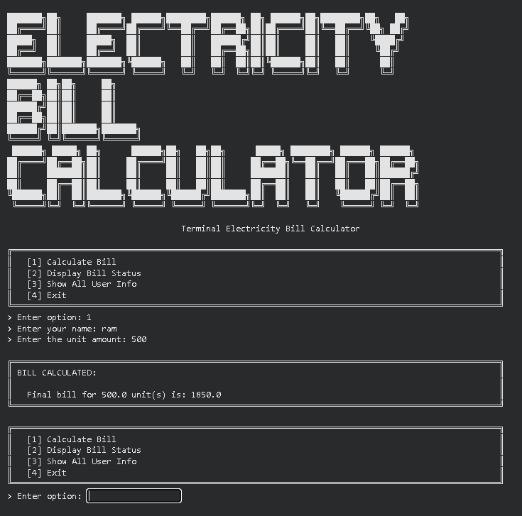

8b. Program 2: ATM Transaction Simulator
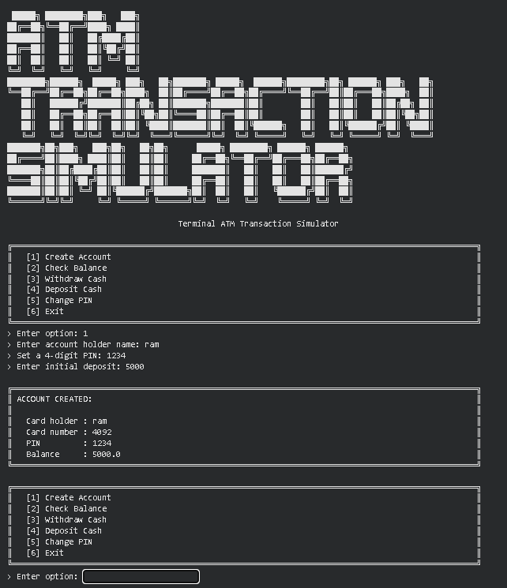

9. Tools & Technologies Used
Tool / Technology | Purpose
Python 3.x | Core programming language for both programs
Python Built-in Features | Functions, dictionaries, input/output, exception handling, and f-strings
Python Dictionaries | Store billing and ATM account records
f-Strings | Format billing and transaction details
Functions & Control Flow | Implement billing, authentication, and transaction logic
Command-Line Interface | Run and test the menu-driven programs
Text Editor / IDE | Write and debug Python code

10. References
- Python Official Documentation
- Python Exception Handling Documentation
- Python String Formatting (f-Strings) Documentation
- Python Dictionaries Documentation
- GeeksforGeeks – Python Electricity Bill Calculator Tutorials
- Brainware University – Python Learning Course Guidelines

11. Signatures
Signature of Student(s): Date of Submission:

Signature of Guide/Supervisor:

